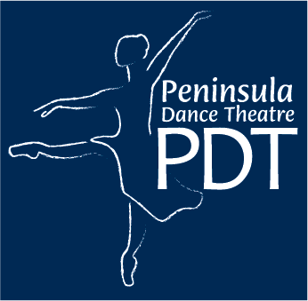
Mallory Morrison, Artistic Director
515 Chester Ave.
Bremerton, WA 98337
(360)-377-6214

I hereby give permission for my child to ride in a carpool of a parent who has completed the PDT “Authorization for use of private auto for student transportation” form which is on file in the company’s office. Please return your completed form to Miss Mallory.

The Permission is for the following company purpose/activity:
Horton Hatches an Egg
October 20, November 7 & 17

Forms Due October 1

__________________________ ________________________ ___________
Parent Signature Printed Name Date

